**Simulation-3**

**Aim: Application of MATLAB for design of three phase 180⁰ and 120⁰ conduction mode inverters.**

**Software Required**

* MATLAB SIMULINK

**Theory:**

**What is a three-phase inverter?**

A three-phase inverter is used to change the DC voltage to three-phase AC supply. Generally, these are used in high power and variable frequency drive applications like HVDC power transmission.

**Working Principle**

A three-phase inverter working principle is, it includes three inverter switches with single-phase where each switch can be connected to load terminal. For the basic control system, the three switches operation can be synchronized so that single switch works at every 60 degrees of basic output waveform to create a line-to-line o/p waveform including six steps. This waveform includes a zero-voltage stage among the two sections like positive &negative of the square-wave. Once PWM techniques based on the carrier are applied to these waveforms, then the basic shape of the waveform can be taken so that the third harmonic including its multiples will be cancelled.

**Three Phase Inverter Design/Circuit Diagram**

The circuit diagram of a three-phase inverter is shown below. The main function of this kind of inverter is to change the input of DC to the output of three-phase AC. A basic 3 phase inverter includes 3 single phase inverter switches where each switch can be connected to one of the 3 load terminals.

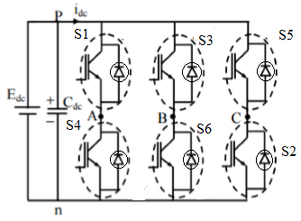*Fig 1- Three Phase Inverter Circuit*

Generally, the three arms of this inverter will be delayed with 120 degrees angle to generate a 3 phase AC supply.  
The switches used in the inverter have 50% of ratio and switching can be occurred after every 60 degrees angle. The switches like S1, S2, S3, S4, S5, and S6 will complement each other. In this, three inverters with single-phase are placed across a similar DC source. The pole voltages within the three-phase inverter are equivalent to the pole voltages within the half-bridge inverter with a single phase.’

The two types of inverters like the single-phase and three-phase include two conduction modes like 180 degrees conduction mode and 120 degrees conduction mode.

180° Conduction Mode

In this conduction mode, each device will be in conduction with 180° where they are activated at intervals with 60°. The output terminals like A, B, and C are connected to the star or 3 phase delta connection of the load.

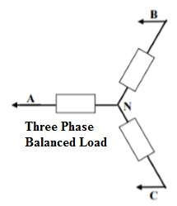

*Fig 2- Three phase balanced load*

The balanced load for three phases is explained in the following diagram. For 0 to 60 degrees, the switches like S1, S5 & S6 are in conduction mode. The load terminals like A & C are linked to the source on its positive point, whereas the B terminal is associated with the source on its negative point. Furthermore, the R/2 resistance is available among the two ends of neutral & the positive whereas R resistance is available among the neutral & the negative terminal.

In this mode, the voltages of load are given in the following.

**VAN = V/3,**

**VBN = −2V/3,**

**VCN = V/3**

The line voltages are given in the following.

**VAB = VAN − VBN = V,**

**VBC = VBN − VCN = −V,**

**VCA = VCN − VAN = 0**

120° Conduction Mode

In this type of conduction mode, every electronic device will be in a conduction state with 120°. It is apt for a delta connection within a load as it results within a six-step kind of waveform across one of its phases. So, at any instant, only these devices will conduct every device that will conduct at 120° only.

The connection of ‘A’ terminal on the load can be done through the positive end whereas the B terminal can be connected toward the negative terminal of the source. The ‘C’ terminal on the load will be in conduction is known as the floating state. Also, the phase voltages are equivalent to the voltages of load which is given below.

Phase voltages are equal to line voltages, so

**VAB = V**

**VBC = −V/2**

**VCA = −V/2**

**Procedure:**

* Firstly, MATLAB Simulink interface should be opened.
* Once, the Simulink is opened, one should open the power libraries in MATLAB.
* Once, the libraries are opened, a MOSFET, DC voltage source, Resistor, mean value, Display, Pulse generator, Multi-meter, RMS, total harmonic distortion, scope and Power Gui are chosen for designing a three phase 180 and 120 conduction mode inverter.
* The parameters of the above components are set to the needs of this simulation.
* All the above components are connected accordingly.
* After the connections are done, the circuit is simulated, after which -25.77 is displayed as the mean value, 91.83 is displayed as RMS value, 0.8488 is displayed as the total harmonic distortion. For the output of the inverter, scope should be pressed. The scope is connected with the pulse generator of MOSFET 3, MOSFET4 and MOSFET 5.
* The output waveforms are obtained through the Scope.

**Circuit Simulated in MATLAB**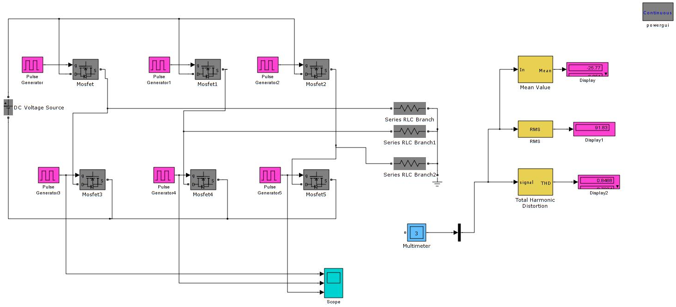

*Fig 3- Simulink circuit of three-phase 180 and 120 conduction mode inverter*

**Output Waveforms obtained:**

**Multimeter Display:**

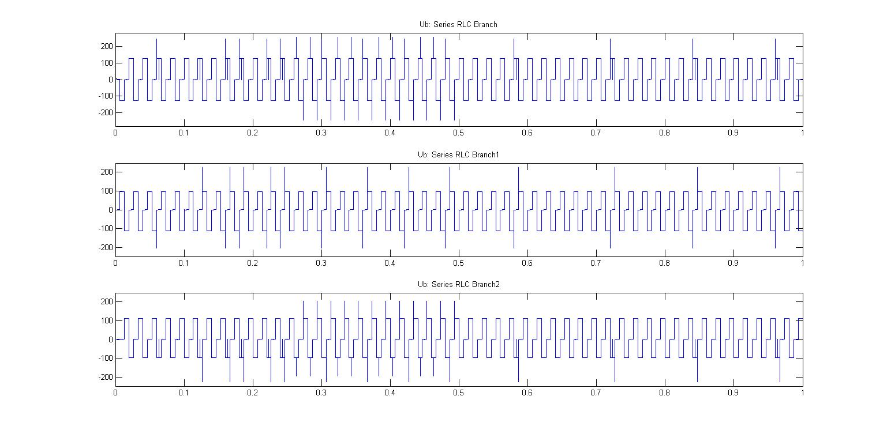

*Fig 4- Display of multimeter voltage readings of the three RLC branches*

**Scope Output:**

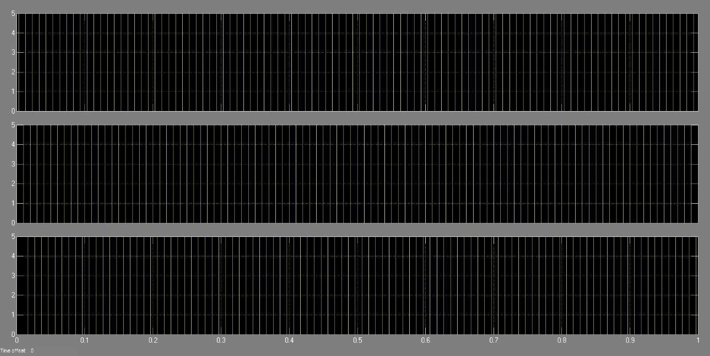

*Fig 5- Scope output of three-phase 180 and 120 conduction mode inverter*

**Result:** The output of three-phase 180 and 120 conduction mode inverter has been obtained in MATLAB Simulink and the result has been verified.